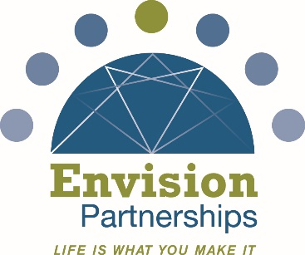

Job Title: Prevention Coordinator

Position Summary
The Prevention Coordinator is responsible for supporting and implementing prevention programs that promote healthy, safe, and resilient individuals, families, and communities. This role focuses on education, outreach, collaboration, and program coordination to reduce risk factors associated with substance misuse, problem gambling, suicide, violence, and other public health concerns. The Prevention Coordinator position engages diverse community partners, and delivers educational programming.

Key Responsibilities
Program & Project Coordination
- Assist in planning, implementing, and evaluating prevention programs and initiatives
- Apply evidence-informed prevention strategies to address individual, family, and community needs
- Coordinate logistics for single or ongoing programs, workshops, and events
- Communicate and collaborate with community partners, schools, youth groups, and other organizations
Education & Direct Service
- Deliver workshops, trainings, and educational presentations to youth, adults, and community stakeholders
- Adapt prevention messaging to meet the needs of diverse audiences
- Represent the organization at community events, coalitions, and conferences
Content Development & Communications
- Support the creation and distribution of prevention-related content, including social media posts, website updates, newsletters, flyers, and marketing materials
- Develop prevention-specific educational materials and campaigns aligned with organizational goals
- Contribute ideas that reflect current trends and emerging community needs
Data Collection & Reporting
- Collect and track data related to program delivery, outreach, and professional development
- Provide monthly reporting requirements
- Maintain organized records to support program evaluation and continuous improvement
Professional Development & Collaboration
- Participate as a collaborative member of a prevention team
- Stay informed about best practices, trends, and changes in the prevention field
- Work toward relevant professional credentials (Ohio Certified Prevention Specialist)

Required Qualifications
- High school diploma
- Strong teamwork, communication, and relationship-building skills
- Ability to manage projects, problem-solve, and balance multiple responsibilities
- Comfort with public speaking and presenting to groups
- Proficiency with common technology platforms (e.g., Google Workspace, Microsoft Office)
- Valid driver’s license, reliable transportation, and willingness to travel
- Ability to work occasional evenings or weekends
- Successful completion of required background checks

Preferred Qualifications
- Bachelor’s degree
- Experience or coursework in prevention, public health, education, social work, or a related field
- Bilingual or multilingual skills (Spanish preferred)
- Familiarity with community-based or nonprofit work

Supervision
- Reports to a designated program or department director
- This position does not include supervisory responsibilities

Work Environment & Schedule
- Full-time (35 hours/week) position with a combination of office-based and community-based work
- Some travel required for programs, meetings, and conferences

Compensation
- This is a full-time position. Compensation details will be discussed during the interview process.
- Envision Partnerships offers a very competitive benefits package that includes paid time off, insurance, reimbursement for gym membership, and retirement.
Equal Opportunity Employer Statement
- Envision Partnerships is an Equal Opportunity Employer and does not discriminate on the basis of race, color, religion, sex, sexual orientation, gender identity or expression, national origin, age, disability, veteran status, or any other protected status under applicable law.
Applicants
- Interested applicants should send their resume and cover letter to Envision Partnerships’ CEO, Lori Higgins at LHiggins@EnvisionPartnerships.com

