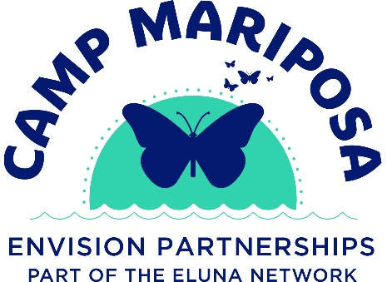
Job Title: Part-Time Camp Mentor
Program: Camp Mariposa of Southwest Ohio
Organization: Envision Partnerships
Schedule: Approximately six weekends per year (Saturday morning–Sunday afternoon) plus occasional trainings and social activities
Commitment: One-year commitment required
Program Overview
Camp Mariposa of Southwest Ohio is a weekend camp program for children ages 9–12 and teens ages 13–16 who have been affected by the substance use disorder of a loved one. The program combines fun, traditional camp activities—such as swimming, canoeing, and archery—with education and support sessions led by mental health professionals and trained adult mentors. There is no cost for families thanks to grant funding.
Camp is held six times per year from Saturday morning through Sunday afternoon. In addition, optional social activities for children and their families are offered throughout the year. All activities are provided free of charge to families. Camp Mariposa offers a safe, fun, and supportive environment that is critical to helping break the cycle of addiction.
Camp Mariposa is a program of the Eluna Network and is managed by Envision Partnerships, a nonprofit organization founded in 1964 that provides innovative behavioral health support services addressing mental health and substance use. Envision Partnerships believes strongly in the resiliency of the human spirit and is committed to instilling hope, inspiring change, and building community.
Position Summary
Camp Mentors are caring, compassionate adults who play a vital role in the success of Camp Mariposa. Mentors provide consistent support, encouragement, and positive role modeling to campers while helping create a safe and inclusive camp environment. Mentors work closely with program staff and mental health professionals to support campers’ emotional growth and resilience.

Key Responsibilities
- Build positive, supportive relationships with campers throughout the one-year commitment
- Participate fully in all camp activities, including recreational and group sessions
- Support campers during structured activities, free time, meals, and overnight stays
- Model healthy communication, boundaries, and coping skills
- Assist with supervision of campers to ensure safety at all times
- Maintain confidentiality and respect the privacy of campers and families
- Attend required trainings, orientations, and debriefings
- Collaborate with staff and fellow mentors to foster a welcoming and supportive camp culture
Qualifications & Requirements
- Must be at least 21 years of age
- Demonstrates compassion, patience, and ability to work with children and teens
- Willingness to work with youth affected by a loved one’s substance use disorder
- Ability to commit to six weekend camps per year and a one-year program commitment
- Ability to participate in outdoor and physical camp activities
- Reliable transportation to and from camp locations and related activities
- Successful completion of a criminal background check and any required screenings
- Completion of required training prior to camp participation
Preferred Qualifications
- Experience working with children or adolescents
- Background in education, social services, mental health, youth development, or related fields
Compensation
This is a stipend position. Compensation details will be discussed during the interview process.
Equal Opportunity Employer Statement
Envision Partnerships is an Equal Opportunity Employer and does not discriminate on the basis of race, color, religion, sex, sexual orientation, gender identity or expression, national origin, age, disability, veteran status, or any other protected status under applicable law.
Point of Contact
For questions or additional information about the Camp Mentor position, contact:
Jamie Simpson
Camp Director, Camp Mariposa of Southwest Ohio
Email: jsimpson@envisionpartnerships.com

