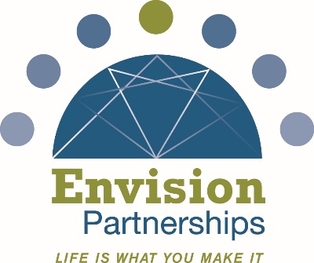
Job Title
Part-Time Family and Community Mediator
Organization
Mediation and Problem Solving (MaPS) is a program of Envision Partnerships, a nonprofit organization founded in 1964 that provides innovative behavioral health support services addressing mental health and substance use. Envision Partnerships believes strongly in the resiliency of the human spirit and is committed to instilling hope, inspiring change, and building community. Our mission is to empower individuals, families, and communities to live healthy, happy, safe, and drug-free.
Location
Butler County, Ohio
(In-person)
Position Type
Part-Time, Independent Contractor
Overview
Envision Partnerships is seeking Community Mediators to provide mediation, dispute resolution, and facilitated problem-solving services through its Mediation and Problem-Solving (MaPS) program. Services are delivered in schools, juvenile court, businesses, and community organizations using a hybrid facilitative and transformative mediation model.
Mediators support families, youth, and community members in resolving conflict, strengthening communication, and building sustainable agreements.
Key Responsibilities
- Facilitate Mediation and Problem-Solving sessions at scheduled sites
- Commit approximately 3 hours per mediation/MaPS session
- Be available for 2–4 mediation/MaPS sessions per month
- Attend all required trainings, supervision sessions, mediator meetings, co-mediations, practice sessions, and professional development activities
- Adhere to all MaPS program standards related to:
  - Confidentiality
  - Ethics and mediator neutrality
  - Mandated reporting requirements
  - Professional competency and ongoing training
- Refrain from providing mediation or related services in Butler County for other organizations without written approval from Envision Partnerships
Qualifications
- Training or experience in mediation, conflict resolution, and/or facilitation is desired
- Ability to work effectively with families, youth, schools, courts, and community organizations
- Strong interpersonal communication, neutrality, and problem-solving skills
- Reliability and professionalism
- Commitment to ethical mediation practices and program guidelines
Training & Support
Envision Partnerships provides:
- Initial and ongoing mediator training
- Technical assistance and supervision
- Session scheduling and program coordination
- Evaluation and research support
Additional Information
The MaPS mediation model and training materials are the intellectual property of Envision Partnerships and may not be shared, taught, or used outside of this program without written permission.
Inquiries
Send resumé and letter of interest to Laura Lamermayer (llamermayer@envisionpartnerships.com).

